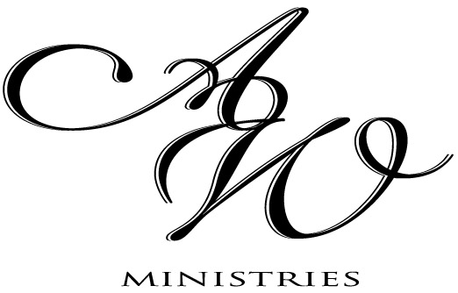
AWM of GRACE HMONG ALLIANCE CHURCH
1418 S. Layton Blvd
Milwaukee, WI 53215
Tel: 414-643-5272

8/31/2013

To: The daughters of the Most High.
I greet you in the Name of our Lord and Savior Jesus Christ. My name is N. Xaliyas Tsab, AWM Director of Grace Hmong Alliance Church in Milwaukee, WI. The AWM Board at GHAC would like to extend a cordial invitation to you and all your friends to our Revival “Living Victoriously / Lub Neej Muaj Yeej”. Our goal is to study the word together, worship, fellowship and equip every woman to live in victoriously in Christ. We know that in every woman’s life, there are many struggles and trials. At times, it may feel like we are fighting a losing battle, but we are not! The bible tells us that we are more than conquerors.
Our keynote speaker is: N. Kxf. Num Nyiaj Hawj. She will be teaching on the theme “Living Victoriously”. The Lord has given her much experience and wisdom on how to live in victory.
We will have four workshop speakers: N. Kxf. Ntxoov Xeeb Yaj will speak on “Win-Win Marriages.” N. Kxf. Ntshab Ntxawg Xoom, will speak on “Women to Women Relationships”. N. Zoov Es Hawj will speak on the victory in “Spiritual Warfare”, and N. Tswv Yis Yaj will speak on “Victorious Stewardship.” Our worship sessions will be by N. Vam Kub Hawj. We will also have a time for healing prayer.
Lunch will be provided for everyone. We ask that if you are coming in groups, please email or rsvp ahead so we know how much food to prepare.
We are excited about what God is doing and will be praying for you.
See you all very soon!!
Your sister in Christ,

N. Xaliyas Tsab
Thawj Niamtsev of Grace Hmong Alliance Church
Cell: 414-841-6879 Email: ctserx@hotmail.com

